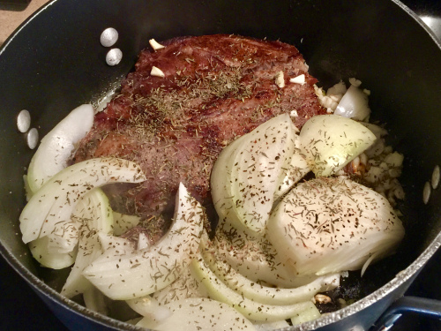Beef Pot Roast

This is a delicious roast to be served with potatoes, celery and carrots on a cold winters night.

Ingredients:

1 beef chuck shoulder pot roast (3 to 3-1⁄2 pounds)
2 tablespoons of grapeseed oil
1 large onion cut into 8 wedges each
2 cloves garlic, peeled
6 potatoes, cut into chunks
2 large carrots, sliced
1 cup beef broth
2 tablespoons cornstarch, dissolved in water
Salt and pepper, to taste

Instructions:
1. Place roast in pot and add onion wedges, garlic, potatoes, celery and carrots. Pour in broth.
2. Cover and cook on low for 4 to 5 hours.
3. Remove roast and vegetables from pot and place on a platter then cover with foil to keep warm. Strain cooking liquid, and skim off fat.
4. In a medium saucepan, combine 2 cups cooking liquid with cornstarch mixture. Bring to a boil, stirring constantly, and cook for 1 minute, or until gravy is thickened.
5. Carve roast into slices, and season with salt and pepper. Serve with vegetables and gravy.

