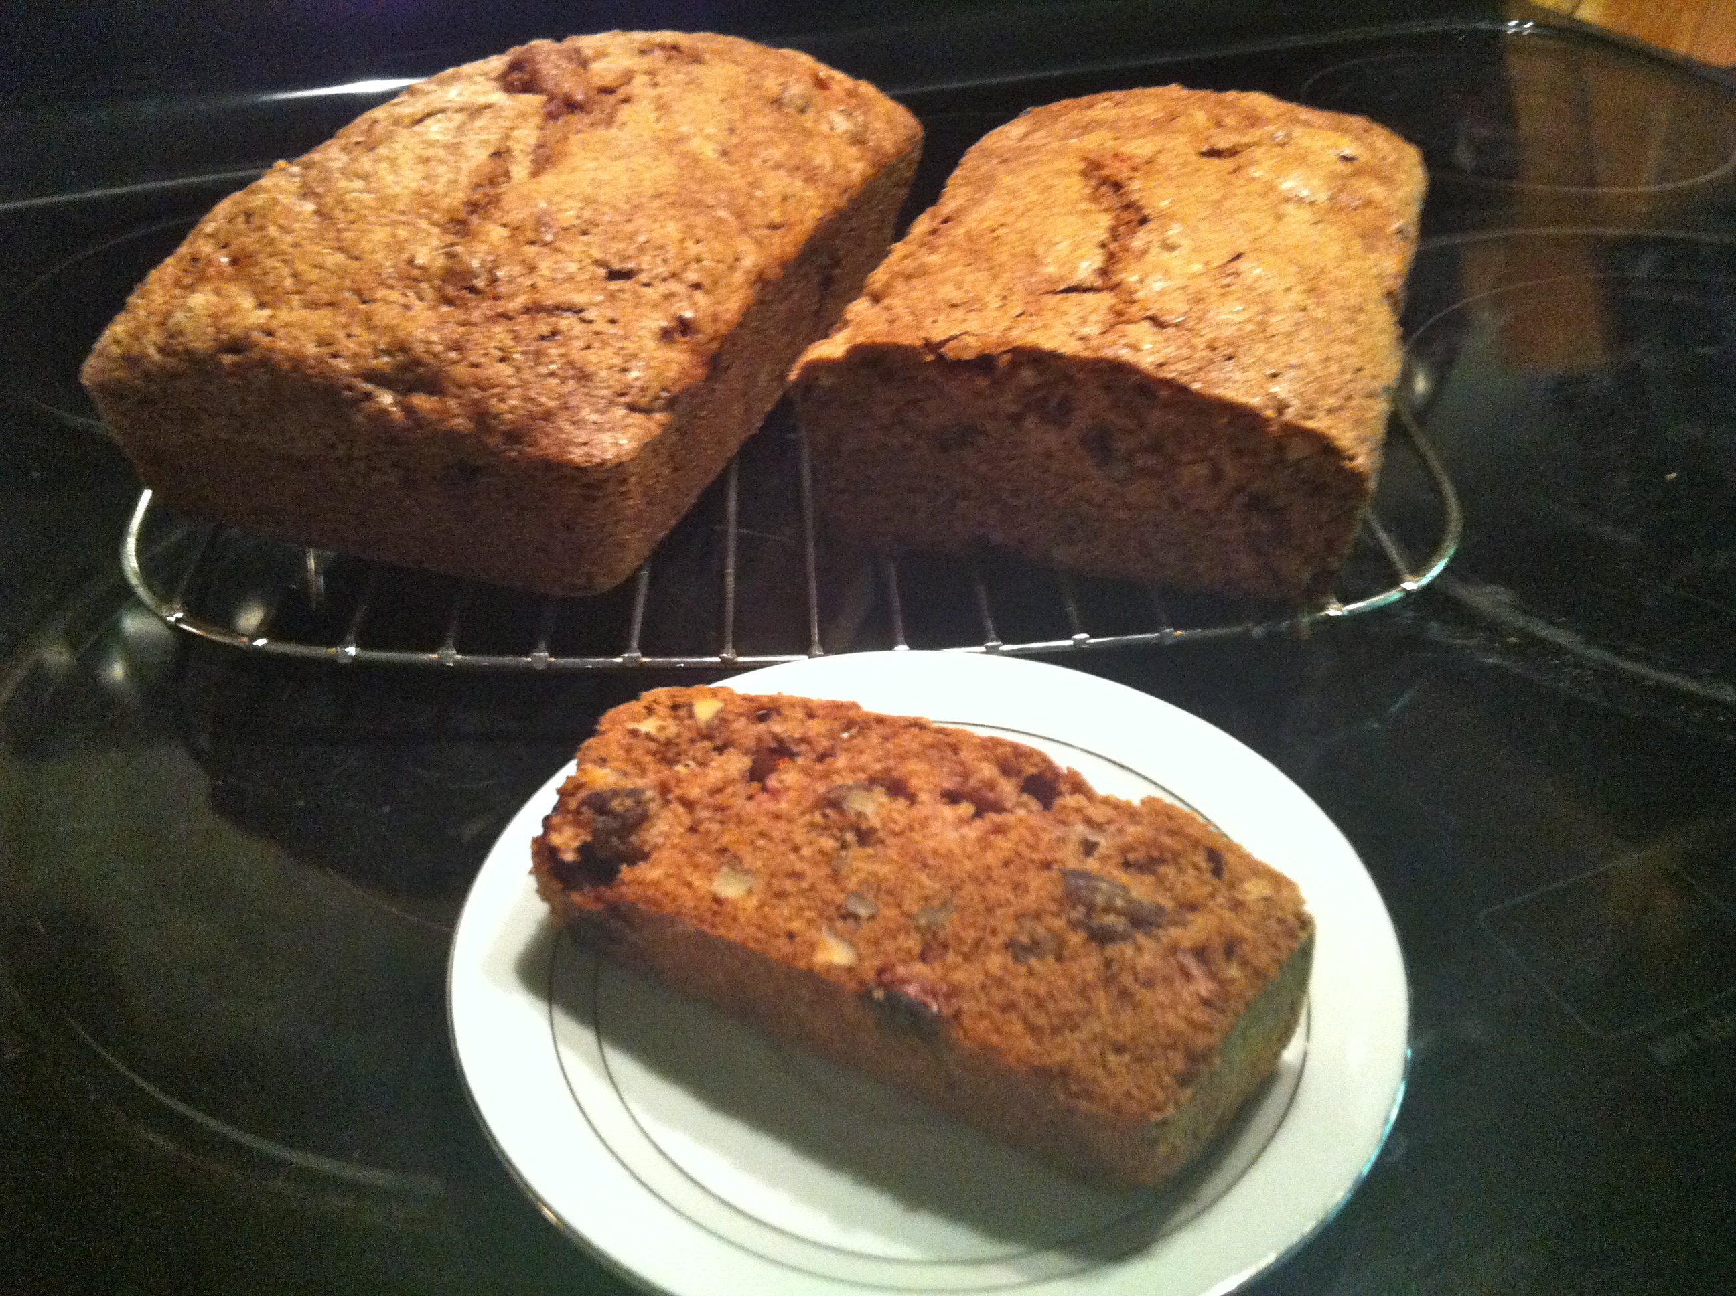

Strawberry Bread Recipe from Stylish Heath
2 ½ cups of sliced fresh strawberries
3 1/8 cups of all-purpose flour
1½ cups of white sugar
1-½ cups of brown sugar
1 teaspoon of salt
¼ teaspoon of nutmeg
1 tablespoon of ground cinnamon
1 heaping teaspoon of baking soda
¼ cups of vegetable oil
4 eggs, beaten
1 cup of chopped pecans

- Preheat oven to 350. Butter and flour two 9 x 5 loaf pans.
- Slice strawberries and place in a bowl. Sprinkle with a bit of sugar and set aside.
- Combine flour, sugar{s}, nutmeg, cinnamon, salt and baking soda; mix well. Fold beaten eggs with the vegetable oil and add to the strawberries. Add the strawberry mixture into the flour mixture and fold gently.
- Add pecans and then divide between two pans.
- Bake in oven for 60 minutes. Cool on rack for 20 minutes and then slice.

If the bread can sit for a day or two the better it will taste. One loaf is perfect for breakfast, and the second can be a tasty treat while at work with a cup of coffee.

Enjoy!!!

